2D Racing Game

This game is a 2D racing game in which you will be controlling a character on a motocross bike racing against either a clock or other competitors. There will be a ‘story’ mode in which you will race through different competitions based in various locations across the world so the level design will be based on stereotypical features of the countries that I choose to involve. Once one country is complete you will be able to move onto the next up with the game getting progressively harder until the final race is unlocked. There will also be a section in which you must travel as far along a course as possible before crashing/ falling off. The further along the track you go the more petrol you use, if you run out of petrol this would also have the same effect of crashing the bike. There will be an option for boosting on both the story mode and the time trial, in the story mode it will be a collectable item which will be used without any input from the user. In the time trail, you will collect a ‘nitrous’ petrol source which will be able to be used without affecting the amount of normal petrol the bike uses.

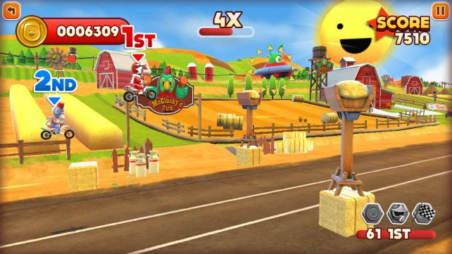The reason I wanted to make this game is because I have recently been playing many racing games and I really enjoy the way the mobile platform integrates with the genre, especially with the 2D racing games. A lot of these games attempt at having realistic art styles but I think I want a more arcade style game, pictured below. This is because in 2014 46% of games played most often were casual / social[1]. Giving it this art style is leaning the game more towards that genre and a wider market.

The mobile games industry grew by 21.3% on year in 2016 accounting for $36.9 billion making it the most popular device to buy games at 37% compared to 31% for console and 32% for PC gaming[2]. This growth in mobile is only predicted to grow over the next three years with some predicting that Chinese games revenues could double to $11.1 billion alone by 2019[3] (Takahashi, 2016). This leads me to believe that this game will most successful on the mobile platform.

Some other 2D racing games for reference including the Hill Climb series in which your character Bill is ‘attempting the ride where no one else has before and conquering the highest hills on the moon’ at the second instalment of the series is #100 in the top free games of any category. The top game is also a racing game, Chameleon Run. This could be classified as a platformer game but the objectives are like that of a time trail racing game. Chameleon Run’s USP is that you must change the character’s colour to match the floor that you are about to land on. My game will be more like the Hill climb series in the way that you will be able to control the car when it is in mid-air as this will provide a greater challenge to user to not crash when racing through the course.

1. http://www.theesa.com/wp-content/uploads/2014/10/ESA_EF_2014.pdf
2. [www.newzoo.com/resources](http://www.newzoo.com/resources)
3. www.venturebeat.com/2016/02/03/chinese-mobile-game-revenues-could-double-to-11-1b-by-2019/